**Home Fire Safety – Activity Sheet**

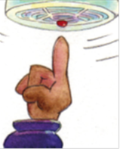**Please read this information on home fire safety – These key messages will help keep you and your family safe at home and could save lives. Once you have finished reading, complete the quiz and see if you can find the answers in the word search. All the answers can be found in the text.**

**Bedtime Routine**

In 2018 most house fires started between the hours of midnight and 6am so it is important that you and your family have a bedtimeroutine. **Every night, before you all go to bed,** you could help by reminding an adult to:

**Close all internal doors fully,**

**Turn off and unplug any unnecessary electrical appliances,**

**Check your oven and/or hob is turned off,**

**Ensure candles are fully extinguished,**

**Keep door and window lock keys in a place where everyone can find them. Your parents should consider taking door keys into their bedroom with them.**

**Escape Plan** - It is important that you and your family know how to escape safely if a fire starts at your home, so you could help the adult you live with create an escape plan.

**Plan an escape route together so everyone knows how to escape**

**Make sure exits and stairways are always kept clear (from toys, shoes, and any obstacles)**

**.A grown up should have access to a phone easily in case they have to ring the emergency services, so it’s a good idea for them to take their mobile to bed at night**

**Keep door and window keys where everyone can find them easily**

**Smoke Alarms -** The easiest and best way to protect yourself and your family from fire is with a smoke alarm. We know that you are **7** times more likely to die in a fire if you don’t have working smoke alarms in your home: **Ask an adult that you live with to check your home to make sure you have working smoke alarms both upstairs and downstairs, to warn you quickly if a fire starts.**

**Every smoke alarm in your house should be tested once a week – You could ask an adult next time they test your smoke alarms if you could watch.**

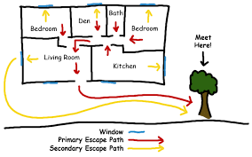.

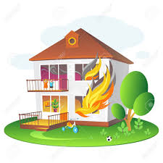**IF YOUR CLOTHES CATCH FIRE -** Don’t run around as you will make the flames worse. You should lie down and roll around. If possible, smother the flames with a heavy material such as a coat or a blanket.

**What to do if there is a fire**

**• Keep calm and act quickly, everyone should get out as soon as possible**

**• Don’t waste time investigating what’s happened or rescuing valuables**

**• Don’t tackle the fire yourself**

**• Before you open a door, check if it’s warm. If it is, don’t open it – fire may be on the other side**

**• If there’s smoke, keep low where the air is clearer.**

**What to do if you can’t get out**

**• If safe to do so everyone should gather into one room, ideally with a window and a phone**

**• Put bedding around the bottom of the door to block out the smoke**

**• Call 999 – an operator will offer survival advice whilst you are on the phone**

**• If you do not have access to a phone, open the window and shout “HELP FIRE”.**

**STOP, DROP AND ROLL!**

**REMEMBER:**

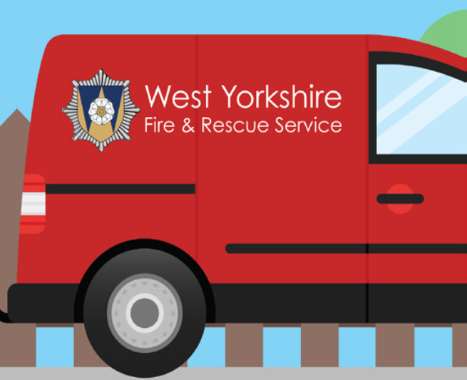

**Home Fire Quiz**

**Complete the quiz and then try and find all 10 answers in the word search – Good Luck!!!**

**Q1. The easiest and best way to alert you that there is a fire is with a** **S_ _ _ E A_ _ _ M**

**Q2. You should test your smoke alarms O_ _ E _ W_ _K**

**Q3. Every night before going to bed, you should follow a B_ _ _ _ _ E R_ _ _ _ _ E**

**Q4. You and your family should create an E_ _ _ _E P_ _ N to ensure you can leave your house safely in the event of a fire.**

**Q5. If you smell smoke and your door is hot, you should open your W_ _ _ _W**

**Q6. What two words should you shout to alert the public there is an emergency, H_ _P and F_ _E**

**Q7. If your clothes catch fire, you should, S_ _P, D_ _P and R_ _L**

